**ADIKAVI NANNAYA UNIVERSITY**

**RAJAMAHENDRAVARAM**

**UNIVERSITY COLLEGE OF ENGINEERING**

Artificially Mobilized Decision Making Car

**Report submitted to**

**DEPARTMENT OF COMPUTER SCIENCE AND ENGINEERING**

**For the award of the degree**

**of**

**BACHELOR OF TECHNOLOGY**

**in**

**COMPUTER SCIENCE AND ENGINEERING**

**by**

**KARROTHU SIVA DURGA ABHINAY**

**Reg. No. 168297601013**



Under the esteemed guidance of

**Dr. M Kamala Kumari, Associate Professor**

**DEPARTMENT OF COMPUTER SCIENCE AND ENGINEERING**

**UNIVERSITY COLLEGE OF ENGINEERING**

**ADIKAVI NANNAYA UNIVERSITY**

**2016-2020**

**ADIKAVI NANNAYA UNIVERSITY**

**RAJAMAHENDRAVARAM**

**UNIVERSITY COLLEGE OF ENGINEERING**

**DECLARATION**

I declare that,

The work contained in this project is work done by me under the guidance of my supervisors. The work has not been submitted to any other institute for any degree or diploma. I have followed the guidelines provided by the university in preparing the report. I have conformed to the norms and guidelines given in the Ethical code of Conduct of the Institute. Whenever I have used materials from other sources, I have given due credit to them by citing them in the text of the report and giving their in the references.

**(Signature of the Student)**

**ADIKAVI NANNAYA UNIVERSITY**

**RAJAHMAHENDFAVARAM**

**UNIVERSTY COLLEGE OF ENGINEERING**



**CERTIFICATE**

This is to certify that the project entitled, ARTIFICIALLY MOBOLIZED DECISION MAKING CAR submitted by **Mr. KARROTHU SIVA DURGA ABHINAY,** **DEPARTMENT OF COMPUTER SCIENCE**, **ADIKAVI NANNAYA UNIVERSITY**, is a record of bonafide Project work carried out by him under my supervision and guidance and is worthy of consideration for the award of the degree of Bachelor Of Technology in Computer Science and Engineering.

____________________ ______________________ ______________________

INTERNAL GUIDE HEAD OF THE EXTERNAL EXAMINER

DEPARTMENT

**ACKNOWLEDGEMENT**

I feel fortunate to pursue my Bachelors Degree from the campus of **Adikavi Nannaya University**. It provided all the facilities in the areas of **COMPUTER SCIENCE AND ENGINEERING.**

It’s a genuine pleasure to express my deep sense of thanks and gratitude to my mentor and project guide **Dr. M Kamala Kumari, Associate Professor**, excellent guidance right from selection of project and his valuable suggestions for me to success, in completing this project in the college. He has given me tremendous support in the technical front.

I profusely thank **Dr.V.Persis,** University college of Engineering for all the encouragement and support**.**

I also thank **Dr.P.Venkateswara Rao, Head of the Department, Department of Computer Science and Engineering** for the guidance throughout the academic.

A great deal of thanks goes to review committee members and the entire faculty members for their support throughout the project.

KARROTHU SIVA DURGA ABHINAY

168297601013

**ABSTRACT**

Over the last few years the automotive industry has advanced significantly towards a future without human drivers. Researchers are currently trying to over- come the technological, political and social challenges involved in making autonomous vehicles mainstream. These vehicles need to be safe, reliable and cost-efficient. Connecting them and creating coordination mechanisms could help achieving these goals.

Self-driving cars are technologically a reality and in the next decade they are expected to reach the highest level of automation. While there is general agreement that an advanced Human-Autonomous Vehicle (HAV) interaction is key to achieve the benefits of self-driving cars, it is less clear what role Artificial Intelligence (AI) should play in this context.

The goal of this project is to develop a Deep learning model using Tensorflow and Keras API that can predict the speed and steering angle of the car based on the road and the obstacles ahead. The car even recognises the Traffic signals and signs. Training data was collected by driving on a wide variety of roads and in a diverse set of lighting and weather conditions. The training data consists of 3 attributes that is image of the road, steering angle and speed. Many famous companies have been doing research on the self driving car. Nvidia is one such company which has developed its own model which has the best accuracy. Nvidia model is been used this project. Nvidia model consists of 9 layers, including a normalization layer, 5 convolutional layers and 3 fully connected layers. The Nvidia model is trained with the training data. The Model is then tested upon a RC car which will simulate a real car on roads. Raspberry Pi, Logitec 270 Webcam, Servo Motor, L298N motor driver module, power bank and 3 18650 batteries are required to build the car. The camera captures the video frames of the road and the frame is then sent to the model that runs on a laptop through TCP socket. Then the model predicts the steering angle of the car using the given video frame. The outputs are then sent to the Raspberry Pi using the TCP socket. Based on the outputs received Raspberry Pi sends the same to the Servo Motor and L298N Driver module resulting in the moment of the car on itself.

**INDEX**

|  |  |  |
| --- | --- | --- |
| S.No. | CONTENT | Page No. |
| 1 | **INTRODUCTION**  1.1 INTRODUCTION TO COVOLUTIONAL  NEURAL NETWORK  1.2 Convolution Neural NetworK  Architecture  1.3 INTRODUCTION TO TENSORFLOW AND KERAS API  1.4 PROJECT SCOPE | **1**  1  2  7  8 |
| 2 | **LITERATURE SURVEY** | **9** |
| 3 | **PROBLEM SPECIFICATION**  3.1 EXISTING SYSTEM  3.2 PROPOSED SYSTEM  3.3 Hardware & Software Requirements  3.3.1 Hardware Requirements  3.3.2 Software Requirements | **11**  11  11  11  11  12 |
| 4 | **METHODOLOGY** | **13** |
| 5 | **SYSTEM ANALYSIS AND DESIGN** | **15** |
| 6 | **SYSYEM ARCHITECTURE** | **20** |
| 7 | **LIBRARIES AND TECHNOLOGIES USED** | **24** |
| 8 | **DEEP LEARNING MODELS**  8.1 NVIDIA MODEL  8.2 MODIFIED LENET MODEL | **27**  27  28 |
| 9 | **SYSTEM IMPLEMENTATION**  9.1 BUILDING THE RC CAR  9.2 TRAINING THE MODIFIED LENET MODEL  9.3 DATA COLLECTION WITH MANUAL MODE  9.4 TRAINING THE NVIDIA MODEL  9.5 TESTING THE MODEL WITH AUTONOMOUS MODE | **30**  30  31  31  32  32 |
| 10 | **CODING**  10.1 CLIENT SIDE CODE (RASPBERRY PI)  10.2 SEVER SIDE CODE | **33**  33  37 |
| 11 | **TESTING AND RESULTS** | **52** |
| 12 | **CONCLUSION** | **55** |
| 13 | **BIBLOGRAPHY** | **56** |

|  |  |  |
| --- | --- | --- |
| Fig. No. | DESCRIPTION | Page No. |
| 10.2.1 | Original Image and Preprocessed Image | 45 |
| 10.2.2 | Model Summary | 47 |
| 10.2.3 | Training Steps | 48 |
| 10.2.4 | Loss vs Epochs graph | 48 |
| 11.2 | Nvidia Model Input | 53 |
| 11.3 | Nvidia Model Output | 53 |
| 11.4 | LeNet Model Input | 54 |
| 11.5 | LeNet Model Output | 54 |

**LIST OF SCREENSHOTS**

**LIST OF FIGURES**

|  |  |  |
| --- | --- | --- |
| **Fig. No.** | **Description** | **Page No.** |
| 1.1 | Image Matrix | 2 |
| 1.2 | Convolution feature map | 3 |
| 1.3 | Padding | 4 |
| 1.4 | Max Polling | 5 |
| 1.5 | ELU graph | 6 |
| 1.6 | Fully Connected Network | 6 |
| 1.7 | Tensor | 7 |
| 1.8 | TensorFlow Logo | 7 |
| 1.9 | Keras Logo | 8 |
| 4.1 | General Steps for Prototyping Model | 13 |
| 5.1 | Manual Mode Use case | 16 |
| 5.2 | Autonomous Mode Use case | 17 |
| 5.3 | Server Class Diagram | 18 |
| 5.4 | Client Class Diagram | 18 |
| 5.5 | Sequence Diagram | 19 |
| 6.1 | Architecture Diagram | 20 |
| 6.2 | Raspberry pi | 21 |
| 6.3 | Logitec C270 webcam | 22 |
| 6.4 | Driver Module | 22 |
| 6.5 | Servo Motor | 23 |
| 8.1 | Nvidia Model Architecture | 27 |
| 8.2 | Modified LeNet Model Architecture | 29 |
| 9.1.1 | RC Car (Frontal View) | 30 |
| 11.1 | RC Car (Top View) | 52 |

**ARTIFICIALLY MOBILIZED DECISION MAKING CAR**

**CHAPTER 1**

**INTRODUCTION**

Usually a Human Driver may or may not follow all the safety and Traffic rules while driving. Speeding, being distracted by happenings inside the car or outside, failing to follow road laws, or driving while tired, drunk, or under the influence of drugs can all be extremely dangerous. Adding just one of these factors to the mix dramatically increases the chances that an accident will happen. In comparison to the myriad of bad behaviours a driver might exhibit behind the wheel, a computer is actually an ideal motorist. Since 81 are the result of human error, computers would take a lot of danger out of the equation entirely.

Over the last few years the automotive industry has advanced significantly towards a future without human drivers. In recent years the development on autonomous cars have increased significantly due to automation in every field and the need of man to make every thing easier. We have developed several ways to automate cars and adding many unique features to the car according to the need but still haven’t added the feature that the car navigates on its own. This features can be very helpful and probably one of the most important feature in future of car and car production management. This will indeed help countless amount of people if used cautiously. In this work we will construct a autonomous RC car which uses a Convolutional Neural Network model and a modified LeNet model to drive itself along the track and detect the traffic signs and lights and act accordingly.

1.1 Introduction to the Convolution Neural Network

Convolution Neural Network (CNN, or Convnet) is class of deep neural networks, most commonly applied to analyzing visual imagery. Convolutional networks were inspired by biological processes in that the connectivity pattern between neurons resembles the organization of the animal cortex.

Convolution Neural Networks, like neural networks, are made up of neurons with learnable weights and biases. Each neuron receives several inputs, take a weighted sum over them, pass it through an activation function and respond with an output. The whole network has a loss function and the tips and tricks that we developed for neural network.

The core operations of training and consequently firing the neurons of the network. It performs the convolution operation over the input consists of a 3-dimensional arrangement of neurons.

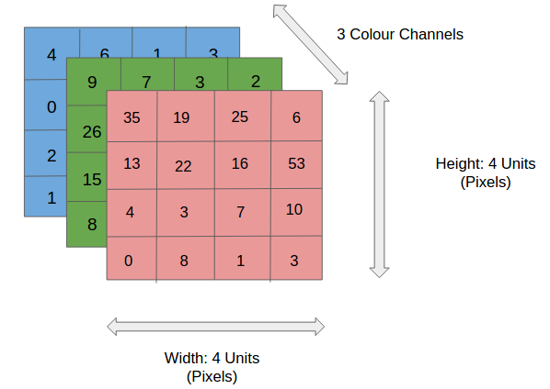

Fig. 1.1 Image Matrix

The cross-section of an input volume of size: 4 x 4 x 3. It comprises of the 3 colour channel matrices of the input image.

1.2 Convolution Neural Network Architecture

* + 1. Convolution Layer & Filters:

Convolution is the first layer to extract features from an input image. Convolution preserves the relationship between pixels by learning image features using small squares of input data. It is a mathematical operation that takes two inputs such as image matrix and a filter or kernel. A filter (or kernel) is an integral component of the layered architecture. It is a smaller-sized matrix in comparison to the input dimensions of the image, that consists of real valued entries. The kernels are then convolved with the input volume to obtain so-called activation maps. Activation maps indicate activated regions, i.e. regions where features specific to the kernel have been detected in the input.

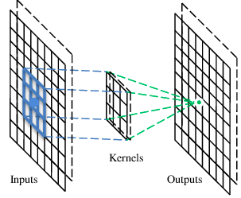

Fig:1.2 Convolution feature map

Strides

Stride is a number of pixels shifts over the input matrix. When the stride is 1 then we move the filters to 1 pixel at a time. Stride is also called as pitch.When the stride is 2 then we move the filters to 2 pixels at a time and so on. The below figure shows convolution would work with a stride of 2.

Formula of stride

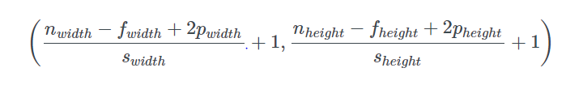

Where *n* is the input dimensional, *f* is the filter size, *p* is the padding, *s* is the stride length.

* + 1. Convolution Operations

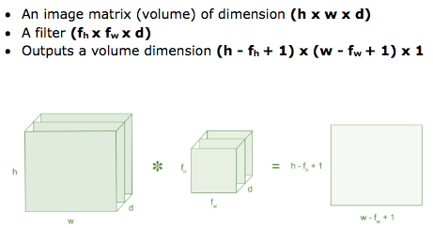

* + 1. Zero Padding

Zero-padding refers to the process of symmetrically adding zeroes to the input matrix. It’s a commonly used modification that allows the size of the input to be adjusted to our requirement.

It is mostly used in designing the CNN layers when the dimensions of the input volume need to be preserved in the output volume.



Fig:1.3 Padding

* + 1. Pooling Layer

The pooling layer is usually placed after the Convolutional layer. Its primary utility lies in reducing the dimensions (Width x Height) of the Input Volume for the next Convolutional Layer. It does not affect the depth dimension of the Volume. The operation performed by this layer is also called ‘down-sampling’, as the reduction of size leads to loss of information as well. The decrease in size leads to less computational overhead for the upcoming layers of the network. It works against over-fitting.

Max Pooling :

Max pooling take the largest element from the rectified feature map. Taking the largest element could also take the average pooling. Sum of all elements in the feature map call as sum pooling.

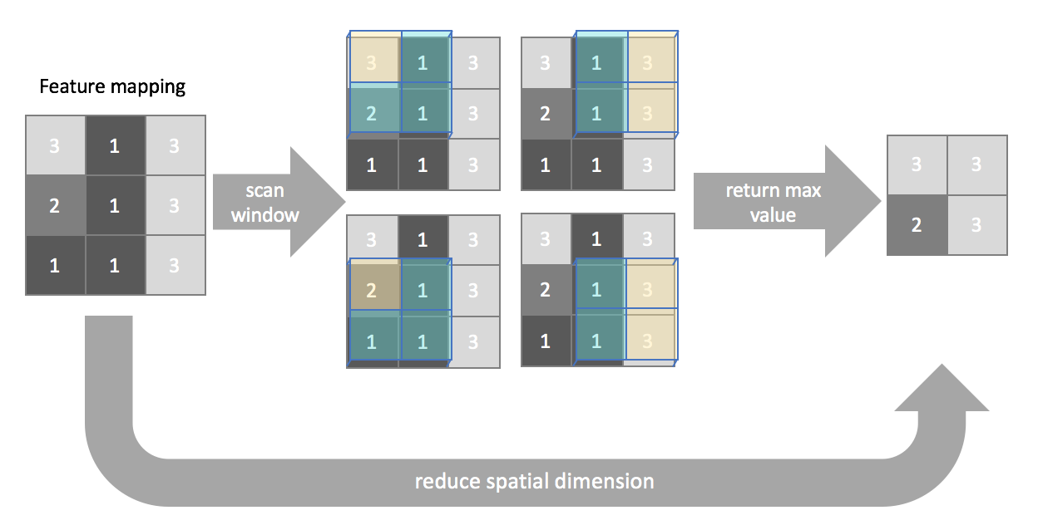

Fig:1.4 Max Pooling

In max pooling, we simply return the maximum value (highlighted in yellow) present inside the window for each scanning location.

* + 1. Activation Functions

The node that you add to the output end of any neural network. It is also known as Transfer Function. It can also be attached in between two Neural Networks. The main purpose is to convert an input signal of a node in Artificial Neural Network to an output signal.

It is used to determine the output of neural network like yes or no. It maps the resulting values in between 0 to 1 or -1 to 1 etc. (depending upon the function).

5.1 Exponential Linear Unit (ELU):

Exponential Linear Unit or its widely known name ELU is a function that tend to converge cost to zero faster and produce more accurate results. Different to other activation functions, ELU has a extra alpha constant which should be positive number.

ELU is very similiar to RELU except negative inputs. They are both in identity function form for non-negative inputs. On the other hand, ELU becomes smooth slowly until its output equal to -α whereas RELU sharply smoothes.

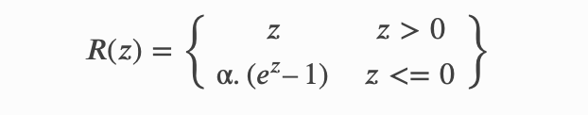



Fig 1.5 ELU graph

* + 1. Fully Connected Layer

Fully-connected layers are typically used in the last stages of the CNN to connect to the output layer and construct the desired number of outputs. The convolutional layers create feature mappings which serve to explain the input in different ways, while the pooling layers compress the spatial dimensions, reducing the number of parameters needed to extract features in following layers. For image classification, we eventually reduce this representation of our original input into a deep stack of 1 by 1 (single value) representations of the original input.

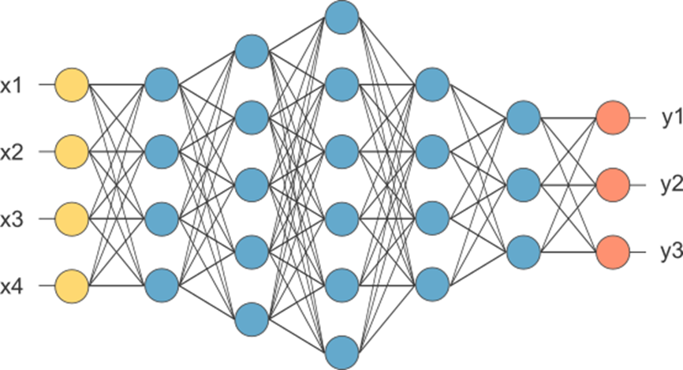

Fig. 1.6 Fully Connected Network

1.3 Introduction to TensorFlow and Keras AI

TensorFlow :

In TensorFlow, the term ‘tensor’ refers to the representation of data as multi-dimensional array which represents the object of consideration whereas the term ‘flow’ refers to the series of operations that one performs on tensors.

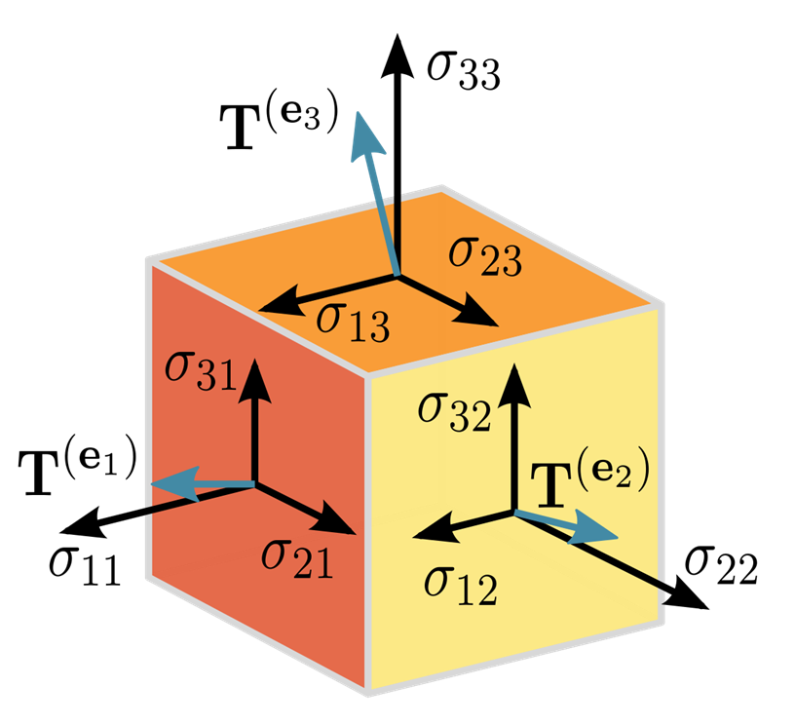

Fig. 1.7 Tensor

TensorFlow is an open source software library released in 2015 by Google to make it easier for developers to design, build, and train deep learning models. TensorFlow originated as an internal library that Google developers used to build models in-house, and we expect additional functionality to be added to the open source version as they are tested and vetted in the internal flavor. Although TensorFlow is only one of several options available to developers, we choose to use it here because of its thoughtful design and ease of use.



Fig. 1.8 TensorFlow Logo

Keras API:

Keras is an open-source [neural-network](https://en.wikipedia.org/wiki/Artificial_neural_network) library written in [Python](https://en.wikipedia.org/wiki/Python_(programming_language)). It is capable of running on top of [TensorFlow](https://en.wikipedia.org/wiki/TensorFlow), [Microsoft Cognitive Toolkit](https://en.wikipedia.org/wiki/Microsoft_Cognitive_Toolkit), [R](https://en.wikipedia.org/wiki/R_(programming_language)), [Theano](https://en.wikipedia.org/wiki/Theano_(software)), or [PlaidML](https://en.wikipedia.org/wiki/PlaidML). Designed to enable fast experimentation with [deep neural networks](https://en.wikipedia.org/wiki/Deep_learning), it focuses on being user-friendly, modular, and extensible. It was developed as part of the research effort of project ONEIROS (Open-ended Neuro-Electronic Intelligent Robot Operating System),and its primary author and maintainer is François Chollet, a [Google](https://en.wikipedia.org/wiki/Google) engineer. Chollet also is the author of the XCeption deep neural network model.

Fig. 1.8 Keras Logo

1.4 Project Scope:

The project scope of this project is to deliver a prototype for the concept which the RC car able to navigate itself through the track with the help of computer vision and Convolution Nueral Network. The project has two scripts that represents Manual mode and Autonomous mode. In Manual model, The user will drive the RC car using Keyboard and user can collect the driving data to train the model. In Autonomous model, The RC car drives itself along the track.

**CHAPTER 2**

**LITERATURE SURVEY**

Parth Verma did a research with the title “The Google Autonomous car”. The Google autonomous car was invented by Sebastian Thrun which was the co-inventor of the Street view mapping service. The strength of this research is that reduces human error while driving and result in decreasing possibility of accident occurring. Better fuel efficiency is achieved when more autonomous car on the road which change the driving habits. Besides that, safety features per-say was included in the autonomous car. Destination can be reached in shorter time which the car able to identify the shortest route. The weakness of this research are when the car is traveling at high speed which over 100mph, the car is hardly to differentiate the objects on the roads.

The CNNs that we describe here go beyond basic pattern recognition. We developed a system that learns the entire processing pipeline needed to steer an automobile. The groundwork for this project was actually done over 10 years ago in a Defense Advanced Research Projects Agency (DARPA) seedling project known as DARPA Autonomous Vehicle (DAVE), in which a sub-scale radio control (RC) car drove through a junk-filled alley way. DAVE was trained on hours of human driving in similar, but not identical, environments. The training data included video from two cameras and the steering commands sent by a human operator.

In many ways, DAVE was inspired by the pioneering work of Pomerleau, who in 1989 built the Autonomous Land Vehicle in a Neural Network (ALVINN) system. ALVINN is a precursor to DAVE, and it provided the initial proof of concept that an end-to-end trained neural network might one day be capable of steering a car on public roads. DAVE demonstrated the potential of end-to-end learning, and indeed was used to justify starting the DARPA Learning Applied to Ground Robots (LAGR) program[[7]](http://en.wikipedia.org/wiki/DARPA_LAGR_Program), but DAVE’s performance was not sufficiently reliable to provide a full alternative to the more modular approaches to off-road driving. (DAVE’s mean distance between crashes was about 20 meters in complex environments.)

About a year ago we started a new effort to improve on the original DAVE, and create a robust system for driving on public roads. The primary motivation for this work is to avoid the need to recognize specific human-designated features, such as lane markings, guard rails, or other cars, and to avoid having to create a collection of “if, then, else” rules, based on observation of these features. We are excited to share the preliminary results of this new effort, which is aptly named: DAVE–2.

A research was did by Michal Ruzicka and Petr Masek with the title “Real Time Visual Marker Detector and Tracker Based on Computer Vision for Semi-autonomous Convoy Purpose”. This research is based control the semi-autonomous convoy by designing the computer vision method. The strength of this research is low power consumption and low cost product. The weakness of this research are using 320 x 240 low resolution of captured frames which will cause the result not accurate. Higher resolution cannot be used because of the low cost power device which does not do well in real time processing due to low frame rate. But this problem can be solve by OpenCL optimization.

Another research was done with the title “Autonomous Three-Wheeled Robot with Computer Vision System”. The research is based on three wheel robot with computer vision. The strength of this research is the product have many feature such as GPS, accelerometer and compass which can use for data collections purpose. Higher accuracy result is achieved with higher resolution and frequency. The weakness of this research is having a bad robot control method which can change to Wi-Fi control that can support further control range. Other than that, the robot cannot operate at dark surroundings. The robot may have problem with the movement of the robot which cannot avoid the obstacles with accurate turning angle of the robot.

**CHAPTER 3**

**PROBLEM SPECIFICATION**

3.1 Existing System:

Existing System is Cars driven by Human. A Human Driver observes the road and traffic ahead of the car and controls the speed and Steering of the Car. The Human Driver should pay 100% concentration upon the road and follow the traffic rules for a safer ride. Speeding, being distracted by happenings inside the car or outside, failing to follow road laws, or driving while tired, drunk, or under the influence of drugs can all be extremely dangerous. Adding just one of these factors to the mix dramatically increases the chances that an accident will happen. Human Driver should have an ethic of following the traffic signs and drive accordingly.

3.2 Proposed System:

A Computer with trained models drives the car instead of a human. The Computer consists of two trained models namely Nvidia model and modified LeNet model and a Camera. The Frame captured by the camera is fed into the model which predicts the Speed and Steering angle of the car. These predicted outputs are passed to the Car’s controller that controls the motor sensor and steering axle. The Car can even sense the objects before it and maintain safe distance to avoid accidents using an ultra sonic sensor.

3.3 Hardware and Software Requirements:

3.3.1 Hardware Requirements:

* Server Processor : Intel I7
* Client device : Raspberry PI B+
* RC Car chasis
* Hard Disk : 256 GB
* RAM : 16 GB
* 32 GB SD card
* Logitec 310 Webcam
* L298N Motor Driver
* Servo Motor
* 3 X 18650 batteries
* 18650 battery holder
* A mobile hotspot or wifi dongle

3.3.2 Software Requirements:

* Server Operating System : MacOS Catalina
* Client Operating System : Raspbian OS
* Software : Python 3.8, Visual Studio Code, VNC Viewer
* Programming Language : Python

**CHAPTER 4**

**Methodology**

Prototyping model was used as the methodology for this project. A prototype is the demo version of the final product and the prototype act as a sample to test the process. Prototype model is defined as a method of system development.

 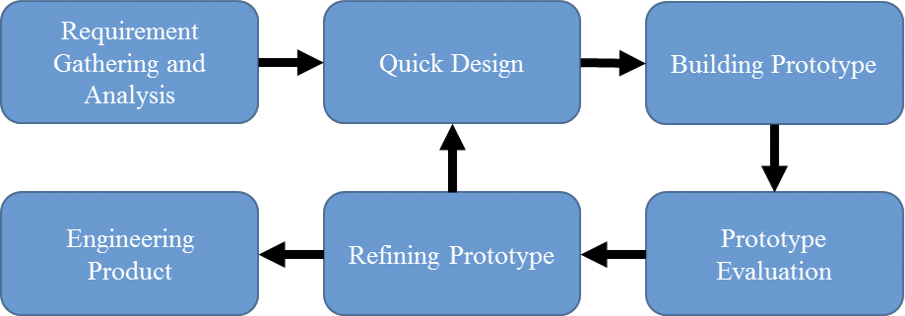

Fig. 4.1 General Steps for Prototyping Model

Explanation for each stage in prototyping model:

* **Requirement Gathering and Analysis**: Before a project is started, all the requirement must be gathered and analyze all the gathered requirement of the system.
* **Quick Design**: A quick design about the system has been generated after the requirement gathering and analysis stage. The important components of the system must be included in the design. By using the quick design, user will able to know how the system works.
* **Building Prototype**: Before the prototype is developed, all of the information that get from the previous stage design is gathered and modified. Those information become the minimum requirement for the system.
* **Prototype Evaluation**: In the process of developing the prototype, the prototype is evaluated with the feedback of user.
* **Refining Prototype**: In this phase, the prototype will be modified depends on the requirement of the user, after the user done assess the prototype. If the user evaluation is good, the finalized system will be created with the finalized prototype specification.
* **Engineering Product**: In this stage, the evaluation and testing must be done on the final product to minimize downtime with the help of life time maintenance.

In this project, the first step is to analyses all the requirements for the project. The hardware components and the software tools are listed down. All of the hardware components datasheet has been studied. Then in quick design stage, the system quick design is created by drawing out the block diagram of the system and flowchart of the system. After that, a prototype RC car was built by using the quick design in the previous stage. Then, user evaluate the prototype RC car and the suggestion and comments are collected. In refining prototype stage, if the prototype RC car does not meet the requirement of customer, the process will back to second stage quick design to redesign the system to fulfil customer requirement. If the customer satisfied with the developed prototype RC car, then it will went to last stage. In final stage, the RC car is evaluated and tested with all possible situations to minimize downtime.

**CHAPTER 5**

**SYSTEM ANALYSIS AND DESIGN**

5.1 Introduction to UML

The unified modeling language allows the software engineer to express an analysis model using the modeling notation that is governed by a set of syntactic semantic and pragmatic rules

A UML system is represented using five different views that describe the system from distinctly different perspective. Each view is defined by a set of diagrams, which is as follows.

UML is a standard language for specifying, visualizing, constructing and documenting the artifacts of software system.

UML was created by object management group (OMG) and UML 1.0 specification draft was proposed to the OMG in January 1997.

OMG is continuously putting effort to make a truly industry standard.

1. UML stands for **U**nified **M**odeling **L**anguage.
2. UML is a pictorial language used to make software blue prints.

So UML can be described as a general purpose visual modeling language

To visualize, specify, construct and document software system. Although UML is generally used to model software systems but it is not limited within this boundary. It is also used to model non software systems as well like process flow in a manufacturing unit etc.

UML is not programming language but tools can be used to generate code in various languages using UML diagrams. UML has a direct relation with object oriented analysis and design. After some standardization UML is become an OMG (Object Management Group) standard.

5.2 Use Case Diagram

A **use case diagram** at its simplest is a representation of a user’s interaction with the system that shows the relationship between the user and the different use cases in which the user is involved. A use case diagram can identify the different types of users of a system and the different use cases and will often be accompanied by other types of diagrams as well.

While a use case itself might drill into a lot of detail about every possibility, a use-case diagram can help to prov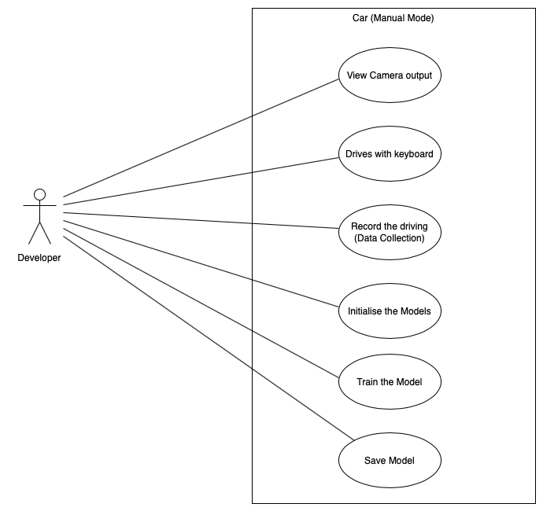ide a higher-level view of the system. It has been said before that “use case diagrams are the blueprints for your system” they provide the simplified and graphical representation of what the system must actually do.

Fig 5.1 Manual Mode Use case

Fig 5.2 Autonomous Mode Use case

5.3 Class Diagram

In software engineering, a **class diagram** in the Unified modelling Language (UML) is a type of static structure diagram that describes the structure of a system by showing the systems classes, their attribute, operations(or methods),and the relationships among objects.

In the diagram, classes are represented with boxes that contain th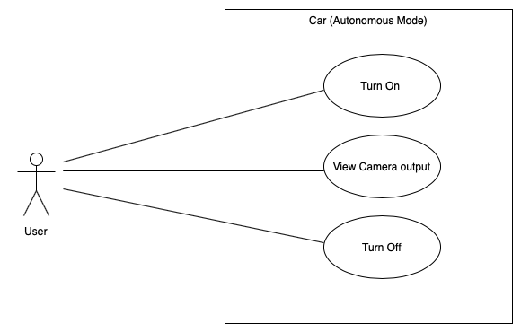ree compartments:

1. The top compartment contains the name of the class. It is printed in bold and centred, and the first letter is capitalized.
2. The middle compartment contains the attributes of the class. They are left-aligned and the first letter is lowercase.
3. The third section is used to describe the operations performed by the class.
4. The fourth section is optional to show any additional components.

Fig 5.3 Server Class Diagram

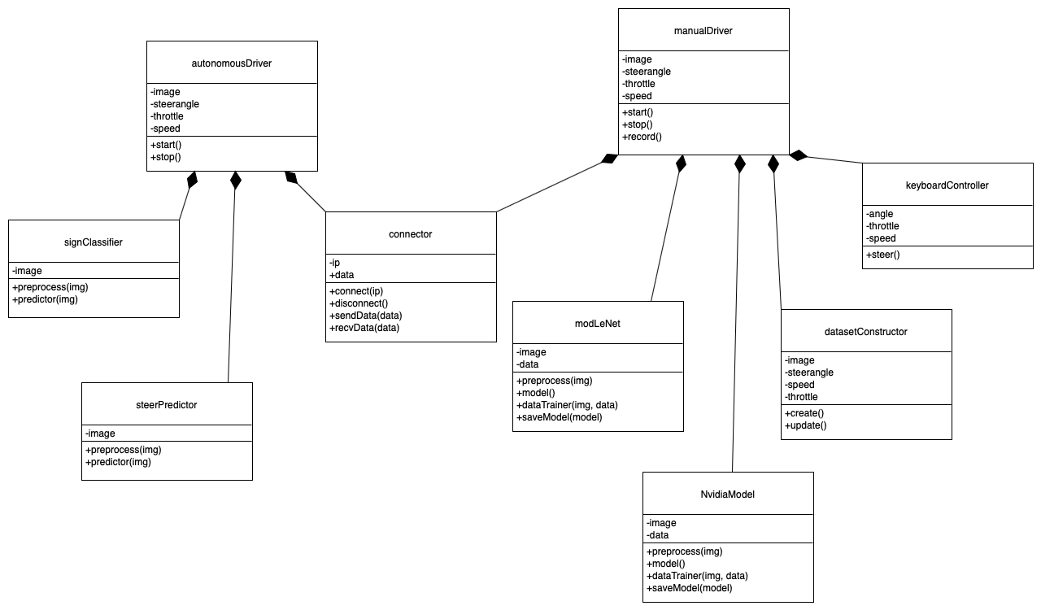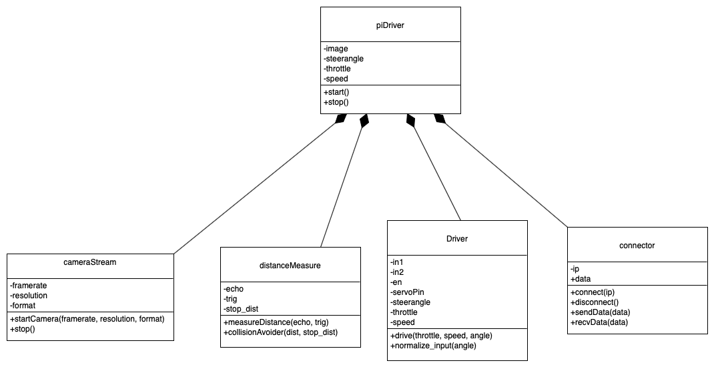

Fig 5.4 Client Class Diagram

5.4 Sequence Diagram

A **sequence diagram** is an interaction diagram that shows how objects operate with one another and in what order. It is a construct of a message sequence chart.

A sequence diagram shows object interactions arranged in time sequence. It depicts the objects and classes involved in the scenario and t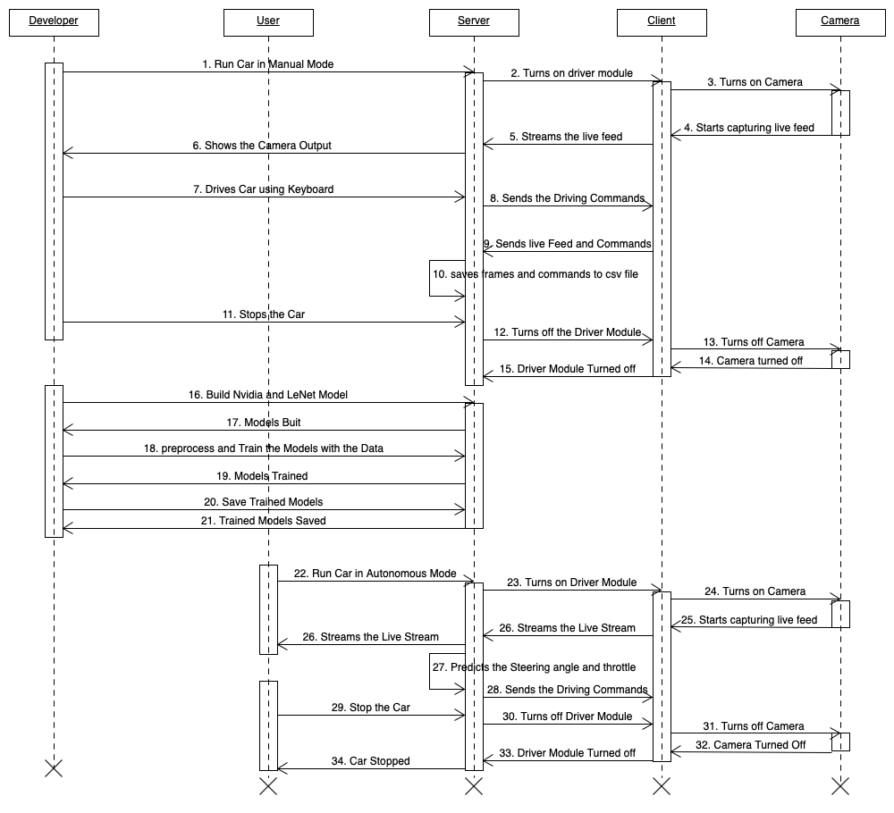he sequence of messages exchanged between the objects needed to carry out the functionality of the scenario. Sequence diagrams are typically associated with use case realizations in the logical view of the system under development. Sequence diagrams are sometimes called **event diagrams** or **event scenarios**.

Fig. 5.5 Sequence Diagram

**CHAPTER 6**

**SYSYEM ARCHITECTURE**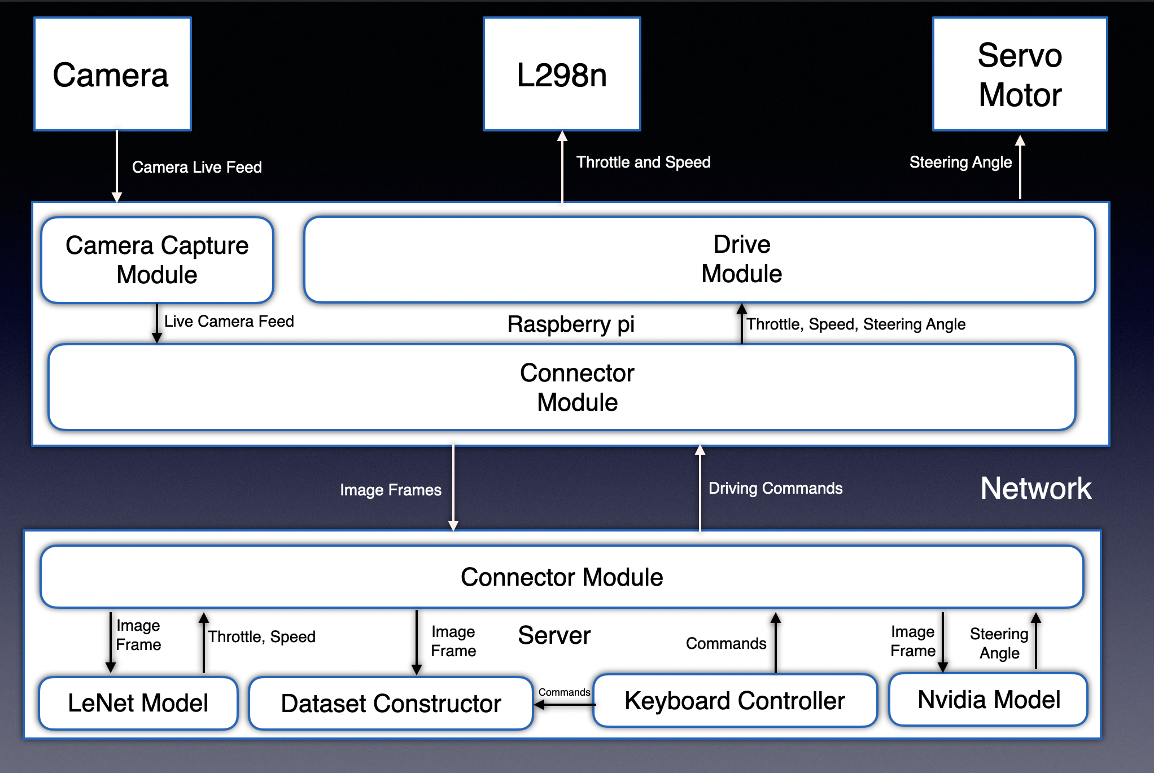

Fig. 6.1 System Architecture

6.1 Server:

It is the main processing system that receives image of the track from the client system using python sockets. It performs the preprocessing and prediction on the given image frame and sends the predictions back to the client using the python sockets. It uses keyboard controller to enable the user to control the car in the manual mode. It has a dataset constructor module which captures the driving commands and the track image into a file which is used to train the model for behaviour cloning of the car. In this project, The server is the laptop which is running MacOS Catalina in this project. It is connected to the client through a mobile hotspot.

6.2 Client:

It is the processor that is within the car. It sends the track images received from the web cam of the car to the server. It receives the driving commands from the server irrespective of the mode and sends the respective instructions to the respective actuators. It is connected to the actuators like L298n motor driver and Servo Motor.

In this project, Raspberry Pi is the client which sends the images and receives the driving instructions from the server i.e the laptop. Raspberry pi runs Raspbian operating system. It has python installed already. It has usb ports that enables us to connect and capture images using web cam and it has GPIO pins which are used to connect with actuators. Raspberry pi is powered by a power bank providing 5v 2A power.

Fig. 6.2 Raspberry pi

6.3 Camera:

Camera is used to captures the image of the track in front of the car which is the input of the model. So, that the model will predict the steering angle. In this project, Logitec c270 webcam is used which is powered via usb.



Fig. 6.3 Logitec c270 webcam

6.4 L298n Motor Driver:

The L298N is a dual H-Bridge motor driver which allows speed and direction control of two DC motors at the same time. The module can drive DC motors that have voltages between 5 and 35V, with a peak current up to 2A. In this project, the L298n is used to control the speed and movement of the car i.e forward or backward.

Fig. 6.4 Driver module

6.5 Servo Motor:

A servomotor is a linear actuator or rotary actuator that allows for precise control of linear or angular position, acceleration, and velocity. It consists of a motor coupled to a [sensor](https://www.electrical4u.com/sensor-types-of-sensor/) for position feedback. It also requires a relatively sophisticated controller, often a dedicated module designed specifically for use with servomotors. In this project, TowerPro MG995 servo motor is used to actuate the steering angle from the client.

Fig. 6.5 Servo motor



C**HAPTER 7**

**LIBRARIES AND TECHNOLOGIES USED**

7.1 Numpy:

NumPy is a library for the Python programming language, adding support for large, multi-dimensional arrays and matrices, along with a large collection of high-level mathematical functions to operate on these arrays. In 2005, [Travis Oliphant](https://en.wikipedia.org/wiki/Travis_Oliphant) created NumPy by incorporating features of the competing Numpy array into Numeric, with extensive modifications. NumPy is [open-source software](https://en.wikipedia.org/wiki/Open-source_software) and has many contributors.

7.2 Sockets:

The Python interface is a straightforward transliteration of the Unix system call and library interface for sockets to Python’s object-oriented style: the socket() function returns a socket object whose methods implement the various socket system calls.Parameter types are somewhat higher-level than in the C interface: as with read() and write() operations on Python files, buffer allocation on receive operations is automatic, and buffer length is implicit on send operations.

7.3 VidGear:

VidGear is a high-performance Video Processing python library that provides an easy-to-use, highly extensible, Multi-Threaded + Asyncio wrapper around many state-of-the-art specialized libraries like [OpenCV](https://github.com/opencv/opencv), [FFmpeg](https://www.ffmpeg.org/), [ZeroMQ](https://zeromq.org/), [picamera](https://github.com/waveform80/picamera), [starlette](https://www.starlette.io/), [pafy](https://github.com/mps-youtube/pafy) and [python-mss](https://github.com/BoboTiG/python-mss) at its backend, and enable us to flexibly exploit their internal parameters and methods, while silently delivering robust error-handling and unparalleled real-time performance.

7.4 Pygame:

Pygame is a set of [Python](http://www.python.org/) modules designed for writing video games. Pygame adds functionality on top of the excellent [SDL](http://www.libsdl.org/) library. This allows you to create fully featured games and multimedia programs in the python language.

Pygame is highly portable and runs on nearly every platform and operating system.

Pygame itself has been downloaded millions of times.

7.5 OpenCv:

OpenCV was started at Intel in 1999 by Gary Bradsky and the first release came out in 2000. Vadim Pisarevsky joined Gary Bradsky to manage Intel’s Russian software OpenCV team. In 2005, OpenCV was used on Stanley, the vehicle who won 2005 DARPA Grand Challenge. Later its active development continued under the support of Willow Garage, with Gary Bradsky and Vadim Pisarevsky leading the project. Right now, OpenCV supports a lot of algorithms related to Computer Vision and Machine Learning and it is expanding day-by-day.

Currently OpenCV supports a wide variety of programming languages like C++, Python, Java etc and is available on different platforms including Windows, Linux, OS X, Android, iOS etc. Also, interfaces based on CUDA and OpenCL are also under active development for high-speed GPU operations.

OpenCV-Python is the Python API of OpenCV. It combines the best qualities of OpenCV C++ API and Python language.

7.6 datetime:

The datetime module supplies classes for manipulating dates and times.

While date and time arithmetic is supported, the focus of the implementation is on efficient attribute extraction for output formatting and manipulation.

7.7 Tensorflow:

TensorFlow is an end-to-end open source platform for machine learning. It has a comprehensive, flexible ecosystem of tools, libraries and community resources that lets researchers push the state-of-the-art in ML and developers easily build and deploy ML powered applications. TensorFlow offers multiple levels of abstraction so you can choose the right one for your needs. Build and train models by using the high-level Keras API, which makes getting started with TensorFlow and machine learning easy. If you need more flexibility, eager execution allows for immediate iteration and intuitive debugging. For large ML training tasks, use the Distribution Strategy API for distributed training on different hardware configurations without changing the model definition.

7.8 Scikit-learn:

Scikit-learn (formerly scikits.learn and also known as sklearn) is a [free software](https://en.wikipedia.org/wiki/Free_software) [machine learning](https://en.wikipedia.org/wiki/Machine_learning) [library](https://en.wikipedia.org/wiki/Library_(computing)) for the [Python](https://en.wikipedia.org/wiki/Python_(programming_language)) [programming language](https://en.wikipedia.org/wiki/Programming_language).[3] It features various [classification](https://en.wikipedia.org/wiki/Statistical_classification), [regression](https://en.wikipedia.org/wiki/Regression_analysis) and [clustering](https://en.wikipedia.org/wiki/Cluster_analysis) algorithms including [support vector machines](https://en.wikipedia.org/wiki/Support_vector_machine), [random forests](https://en.wikipedia.org/wiki/Random_forests), [gradient boosting](https://en.wikipedia.org/wiki/Gradient_boosting), [k-means](https://en.wikipedia.org/wiki/K-means_clustering) and [DBSCAN](https://en.wikipedia.org/wiki/DBSCAN), and is designed to interoperate with the Python numerical and scientific libraries [NumPy](https://en.wikipedia.org/wiki/NumPy) and [SciPy](https://en.wikipedia.org/wiki/SciPy).

7.9 Matplotlib:

Matplotlib is a [plotting](https://en.wikipedia.org/wiki/Plotter) [library](https://en.wikipedia.org/wiki/Library_(computer_science)) for the [Python](https://en.wikipedia.org/wiki/Python_(programming_language)) programming language and its numerical mathematics extension [NumPy](https://en.wikipedia.org/wiki/NumPy). It provides an [object-oriented](https://en.wikipedia.org/wiki/Object-oriented_programming) [API](https://en.wikipedia.org/wiki/API) for embedding plots into applications using general-purpose [GUI toolkits](https://en.wikipedia.org/wiki/GUI_toolkit) like [Tkinter](https://en.wikipedia.org/wiki/Tkinter), [wxPython](https://en.wikipedia.org/wiki/WxPython), [Qt](https://en.wikipedia.org/wiki/Qt_(software)), or [GTK+](https://en.wikipedia.org/wiki/GTK%2B). There is also a [procedural](https://en.wikipedia.org/wiki/Procedural_programming) "pylab" interface based on a [state machine](https://en.wikipedia.org/wiki/State_machine) (like [OpenGL](https://en.wikipedia.org/wiki/OpenGL)), designed to closely resemble that of [MATLAB](https://en.wikipedia.org/wiki/MATLAB), though its use is discouraged.[SciPy](https://en.wikipedia.org/wiki/SciPy) makes use of Matplotlib.

Matplotlib was originally written by [John D. Hunter](https://en.wikipedia.org/wiki/John_D._Hunter), since then it has an active development community,and is distributed under a [BSD-style license](https://en.wikipedia.org/wiki/BSD_licenses).

**CHAPTER 8**

**DEEP LEARNING MODELS**

8.1 NVIDIA MODEL

The network architecture consists of 9 layers, including a normalization layer, 5 convolutional layers, 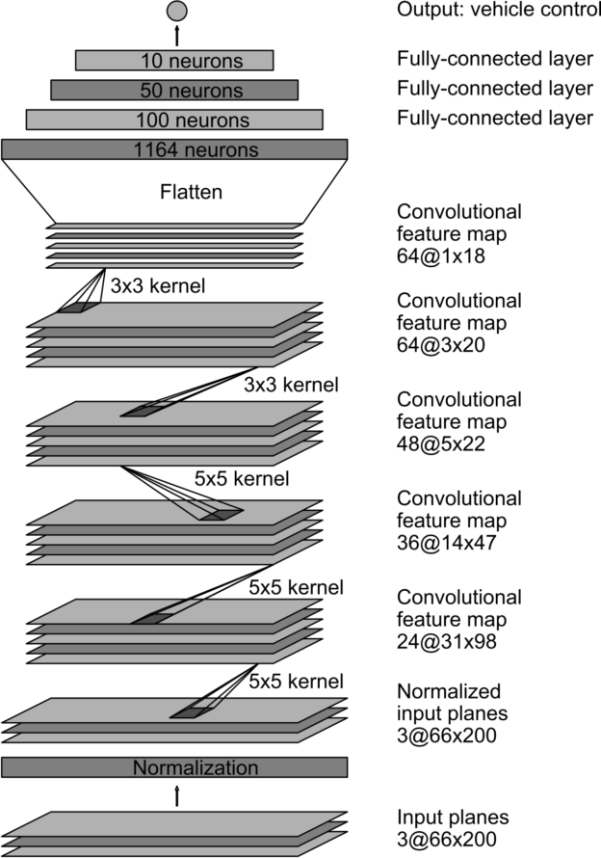and 3 fully connected layers. The input image is split into YUV planes and passed to the network.

Fig 8.1 Nvidia model architecture

The first layer of the network performs image normalization. The normalizer is hard-coded and is not adjusted in the learning process. Performing normalization in the network allows the normalization scheme to be altered with the network architecture, and to be accelerated via GPU processing. The convolutional layers are designed to perform feature extraction, and are chosen empirically through a series of experiments that vary layer configurations. We then use strided convolutions in the first three convolutional layers with a 2×2 stride and a 5×5 kernel, and a non-strided convolution with a 3×3 kernel size in the final two convolutional layers. We follow the five convolutional layers with three fully connected layers, leading to a final output control value which is the inverse-turning-radius. The fully connected layers are designed to function as a controller for steering, but we noted that by training the system end-to-end, it is not possible to make a clean break between which parts of the network function primarily as feature extractor, and which serve as controller.

8.2 Modified LeNet Model:

This Architecture consists of 4 Convolution layers, 2 Max pool Layers and 3 fully connected networks with a Softmax activation as an output layer. The image of a traffic sign or signal is given as an input. Then the network classifies the input image to a traffic sign.

The first two convolution layers having 60 filters with kernel size of 28 by 28 to extract the complex features and they are followed by a max pool layer to reduce the size and then another two layers of convolution layers with 30 filters of kernel size 10 by 10 and 8 by 8. This is followed by another max pool layer. Then the resultant future maps are flattened to fed into the fully connected layers. Where the adjustment of weights happen during the training phase. And The prediction of the traffic signal happens during the testing phase.

Fig.8.2 Modified LeNet Model Architecture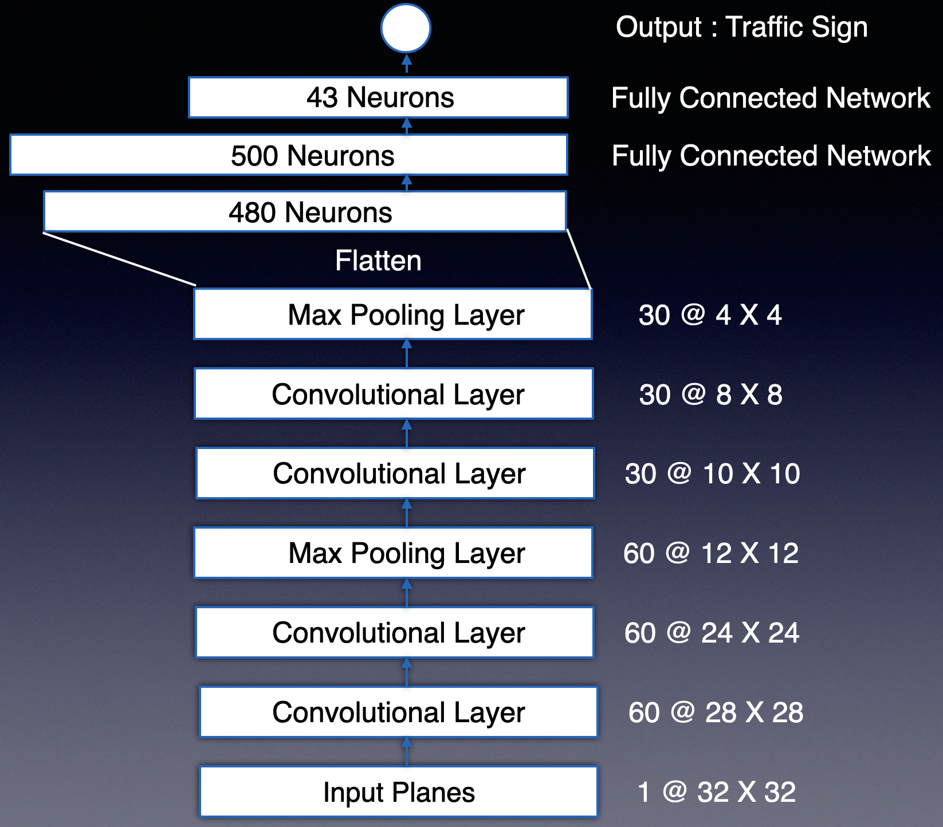

**CHAPTER 9**

**SYSTEM IMPLEMENTATION**

**9.1 BUILDING THE RC CAR**

1. A Normal RC car is taken and then the IC provided with it that is responsible for remote control operations and the DC motor that steers the the RC car is removed.
2. A servo motor is placed in the place of the DC motor at the steering axle, as servo motor has the capability to rotate in certain angle.
3. The Raspberry pi is mounted upon the RC car. As it plays the role of the client and manages various tasks like controlling the actuators, capture the camera images and exchanging data with the server.
4. A Power bank is even mounted on the top of the car, as Raspberry pi need a consistent power source to work perfectly. The power is drawn from the power bank.
5. Logitec c310 web cam is then mounted on the top of the car it is connected to the USB port of the Raspberry pi.
6. Then TB6612 motor driver is connected to the DC motor that runs the back wheels and the Raspberry pi GPIO pins.
7. The motor driver is powered by a 18650 Li Ion battery. This power is used by the motors too.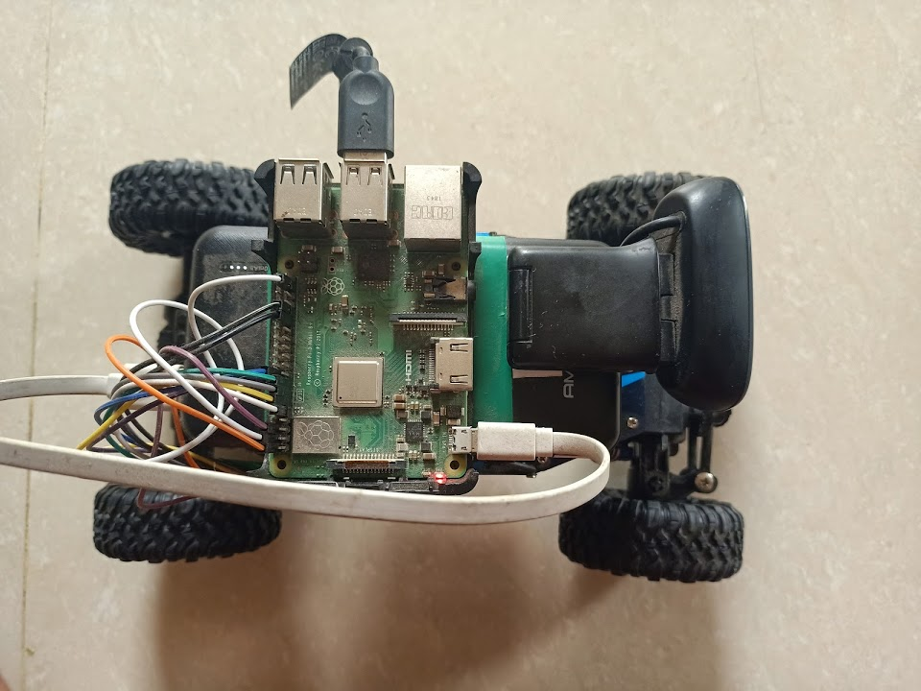

Fig 9.1.1 RC Car

**9.2 TRAINING THE MODIFIED LENET MODEL**

1. The Traffic signs dataset is downloaded from this url <http://benchmark.ini.rub.de/?section=gtsrb&subsection=dataset>
2. Open and run all the cells in Traffic Signs Identifier.ipynb file
3. Start Training by executing the training cell.
4. Then at the end the trained model is saved in the current folder in the format of h5
5. This saved model can be imported into a program and perform traffic signs classification.

**9.3 DATA COLLECTION WITH MANUAL MODE**

1. First make sure that the server(Computer) and Client (Raspberry pi) are connected to the same network.
2. Run the Manual mode.py file in the Server.
3. Then Run the Client_module.py file in the client module.
4. When the connection between the server and client is established successfully then a window pops up showing the camera feed from the car on the screen of the server.
5. Then Car can be controlled using the keyboard of the server. The arrows keys on the keyboard will make the car to move.
6. Pressing Up arrow gives the throttle to the car which makes it moves it forward and on releasing it the stops car from moving forward.
7. Using left and right arrow keys to steer the car left and right.
8. Using the back arrow the car starts moving in reverse direction.
9. The following keys: ‘a', ’s’, ‘d’ controls the speed of the car where ‘a' makes the car speed slow, ’s' makes car speed medium and ‘d’ makes car move in full speed.
10. By Pressing the ‘r’ will toggle the recording option, when enabled will collect both image from the web cam and the driving commands like throttle, speed and steering angle.
11. The images are saved to the ‘data/training_images’ folder. Each image is name with the timed date of its capture. And the driving commands are stored into a numpy save file with name ‘driving_data.npz’.
12. Pressing ‘q’ will close the connection between the server and client and closes the camera display.
13. The car is driven over a road build using two ropes acting as edges of the road.

**9.4 TRAINING THE NVIDIA MODEL**

1. Make sure that driving data in ‘driving_data.npz’ is not empty by executing ‘data collector length.py’ file
2. Open ‘Behavioural Cloning.ipynb’ and execute all the cells the cells.
3. Preprocess the data and train the model by executing the respective cells in the Jupyter notebook.
4. At the end save the trained model with the name ‘driver.h5’

**9.5 TESTING THE MODEL WITH AUTONOMOUS MODE**

1. First make sure that the server(Computer) and Client (Raspberry pi) are connected to the same network.
2. Run ‘Autonomous_mode.py’ file in the server.
3. Then Run the Client_module.py file in the client module.
4. When the connection between the server and client is established successfully then a window pops up showing the camera feed from the car on the screen of the server.
5. The pre trained model is loaded in to the environment and is made ready to predict the steering angles based on the road captured in the camera.
6. If key ’s’ is pressed them the car starts moving autonomously along the road of two ropes.
7. The speed of the car can be changed using the keys ‘a’, ‘d’, ‘f’ indicating slow medium and high respectively.
8. The car is driven at low medium usually for better accuracy. As to over come the network delay between the server and client.
9. Pressing key ‘w’ will stop the car from moving.
10. Finally, Press ‘esc’ to close the connection between the server and client and closes the camera display.

**CHAPTER 10**

**CODING**

**10.1 CLIENT SIDE CODE (RASPBERRY PI)**

**Driver.py:**

**#imports**

import RPi.GPIO as GPIO

from time import sleep

**#Define the drive class**

class Driver(object):

**#constructor definition**

def __init__(self):

self.in1 = 23

self.in2 = 24

self.ena = 27

self.in3 = 6

self.in4 = 5

self.enb = 26

self.standby = 22

self.servo = 17

GPIO.setmode(GPIO.BCM)

GPIO.setup(self.in1, GPIO.OUT)

GPIO.setup(self.in2, GPIO.OUT)

GPIO.setup(self.ena, GPIO.OUT)

GPIO.setup(self.in3, GPIO.OUT)

GPIO.setup(self.in4, GPIO.OUT)

GPIO.setup(self.enb, GPIO.OUT)

GPIO.setup(self.standby, GPIO.OUT)

GPIO.setup(self.servo, GPIO.OUT)

self.p1 = GPIO.PWM(self.ena, 1000)

self.p2 = GPIO.PWM(self.enb, 1000)

self.steer = GPIO.PWM(self.servo, 50)

self.p1.start(25)

self.p2.start(25)

self.steer.start(90)

GPIO.output(self.in1, GPIO.LOW)

GPIO.output(self.in2, GPIO.LOW)

GPIO.output(self.in3, GPIO.LOW)

GPIO.output(self.in4, GPIO.LOW)

**#Defining Drive function**

def drive(self, throttle, speed, angle):

print("Angle:", angle)

if throttle == 1:

GPIO.output(self.standby, GPIO.HIGH)

GPIO.output(self.in1, GPIO.HIGH)

GPIO.output(self.in2, GPIO.LOW)

GPIO.output(self.in3, GPIO.HIGH)

GPIO.output(self.in4, GPIO.LOW)

print("Forward")

elif throttle == 2:

GPIO.output(self.standby, GPIO.HIGH)

GPIO.output(self.in1, GPIO.LOW)

GPIO.output(self.in2, GPIO.HIGH)

GPIO.output(self.in3, GPIO.LOW)

GPIO.output(self.in4, GPIO.HIGH)

elif throttle == 0:

GPIO.output(self.standby, GPIO.LOW)

GPIO.output(self.in1, GPIO.LOW)

GPIO.output(self.in2, GPIO.LOW)

GPIO.output(self.in3, GPIO.LOW)

GPIO.output(self.in4, GPIO.LOW)

self.p1.ChangeDutyCycle(speed)

self.p2.ChangeDutyCycle(speed)

if angle <= 60:

angle = 60

elif angle >= 130:

angle = 130

angle = 2+(angle/18)

self.steer.ChangeDutyCycle(angle)

def clean(self):

GPIO.cleanup()

**Client_module.py:**

**#imports**

from Driver import Driver

import cv2

import socket

from vidgear.gears import NetGear

import pickle

from threading import Thread

from time import sleep

**#initializing global variables**

host = ‘192.168.43.251' #IP of server

video_port = '8000'

command_port = 8001

**#define steer function**

def steer():

global command_client

global driver

global recv_inst

try:

while recv_inst:

data = command_client.recv(53)

if data is not None:

data = pickle.loads(data)

print(data)

if data == b'quit':

recv_inst = False

driver.drive(0,0,90)

break

else:

t = data['throttle']

s = data['speed']

a = data['angle']

driver.drive(t,s,a)

else:

driver.drive(0,0,90)

except:

driver.drive(0,0,90)

command_client.close()

**#Defining the video streamer**

def VideoStream():

global command_client

global driver

global recv_inst

print("Started")

driver = Driver() #initializing the driver class object

recv_inst = True

command_client = socket.socket()

command_client.connect((host, command_port))  
 **#start a thread of steering function**

Thread(target = steer).start()

sleep(1)

cam = cv2.VideoCapture(0)

client = NetGear(address = host, port = video_port, protocol = 'tcp', pattern = 0, recieve_mode = False, logging = False)

cam.set(3, 320)

cam.set(4, 240)

#cam.set(cv2.CAP_PROP_FPS, 10)

while recv_inst:

ret, frame = cam.read()

if frame is None:

break

cv2.imshow("Car Cam", frame)

client.send(frame)

if cv2.waitKey(1) & 0xFF == ord('q'):

break

cam.release()

client.close()

command_client.close()

cv2.destroyAllWindows()

Thread(target = VideoStream).start()

**10.2 SEVER SIDE CODE**

**manual_mode.py:**

**#imports**

import socket

from vidgear.gears import NetGear

import pickle

import pygame

from pygame.locals import *

from time import sleep

import cv2

import threading

import numpy as np

import datetime

def command_center(): #Main method

print('Started')

global send_inst

global image

global command

global command_connection

global record

pressed_u = False

pressed_b = False

pressed_l = False

pressed_r = False

a = False

b = False

c = False

d = False

throttle = 0

angle = 90

data = {'throttle':0, 'speed':0, 'angle':90}

done = 0

speed = 50

send_inst = True

print("Thread Started")

#initialize pygame which enables us to capture the keyboard key press

pygame.init()

pygame.display.set_mode((250, 250))

#initialize the host ip address, port numbers of command and video communication

host = '192.168.43.251'

command_port = 8001

video_port = '8000'

try:

#initialize command socket

command_socket = socket.socket()

command_socket.bind((host, command_port))

#listen to the connections until one is found

command_socket.listen(0)

command_connection, addr = command_socket.accept()

print("Connected to", addr)

sleep(0.5)

#Initialize video socket using VIDGEAR package

server = NetGear(address=host, port=video_port, protocol='tcp', pattern=0, receive_mode= True)

while send_inst:

image = server.recv()

#image = lane_detector.detect_lanes(image)

cv2.imshow("Car View", image)

if image is None:

print("Image is none")

break

for event in pygame.event.get():

if event.type == pygame.KEYDOWN:

key_input = pygame.key.get_pressed()

if key_input[pygame.K_a]:

speed = 20

if key_input[pygame.K_s]:

speed = 30

if key_input[pygame.K_d]:

speed = 40

if key_input[pygame.K_f]:

speed = 50

if key_input[pygame.K_UP]:

pressed_u = True

a = True

if key_input[pygame.K_DOWN]:

pressed_b = True

b = True

if key_input[pygame.K_LEFT]:

pressed_l = True

c = True

if key_input[pygame.K_RIGHT]:

pressed_r = True

d = True

if key_input[pygame.K_ESCAPE]:

command = b'quit'

command_connection.send(command)

send_inst = False

if key_input[pygame.K_r]:

if record == 0:

print("Recording")

record = 1

elif record == 1:

record = 0

print("Stopped Recording")

elif event.type == pygame.KEYUP:

if a and event.key == pygame.K_UP:

pressed_u = False

throttle = 0

a = False

if b and event.key == pygame.K_DOWN:

pressed_b = False

throttle = 0

b = False

if c and event.key == pygame.K_LEFT:

pressed_l = False

angle = 90

c = False

if d and event.key == pygame.K_RIGHT:

pressed_r = False

angle = 90

d = False

if pressed_u :

throttle = 1

if pressed_b :

throttle = 2

if pressed_l:

if angle < 180:

angle += 10

sleep(0.1)

if pressed_r:

if angle > 0:

angle -= 10

sleep(0.1)

if angle != data['angle'] or throttle != data['throttle']:

command = {'throttle':throttle, 'speed':speed, 'angle':angle}

data['angle'] = angle

data['throttle'] = throttle

print(command)

command = pickle.dumps(command)

command_connection.send(command)

elif command == 'quit':

command = b'quit'

command_connection.send(command)

if record == 1 and throttle == 1:

image_name = str(datetime.datetime.now()).replace(" ", "_").replace(":", "_").replace(".","_")+".jpg"

image_path = "Data/training_images/"+image_name

cv2.imwrite(image_path, image)

file_name = "Data/driving_data.npz"

temp_data = np.load(file_name)

image_array = temp_data['images_paths'].tolist()

throttle_array = temp_data['throttle'].tolist()

speed_array = temp_data['speed'].tolist()

angle_array = temp_data['angle'].tolist()

image_array.append(image_path)

throttle_array.append(throttle)

speed_array.append(90)

angle_array.append(angle)

image_array = np.array(image_array)

throttle_array = np.array(throttle_array)

speed_array = np.array(speed_array)

angle_array = np.array(angle_array)

np.savez(file_name, images_paths = image_array, throttle = throttle_array, speed = speed_array, angle = angle_array)

except:

cv2.destroyAllWindows()

server.close()

command_socket.close()

if __name__ == '__main__':

send_inst = True

command = 'a'

record = 0

command_center()

**Behaviour Cloning:**

#imports

# In[1]:

import numpy as np

import ntpath

import keras

import matplotlib.pyplot as plt

import matplotlib.image as mtimg

from tensorflow.keras.models import Sequential

from tensorflow.keras.optimizers import Adam

from tensorflow.keras.layers import Convolution2D, MaxPooling2D, Dropout, Dense, Flatten

from sklearn.model_selection import train_test_split

from sklearn.utils import shuffle

import pandas as pd

import cv2

from imgaug import augmenters as iaa

import os

import random

import numpy as np

import tensorflow as tf

# In[2]:

path = 'Data/driving_data.npz'

data = np.load(path)

# In[3]:

input_angle_data = data['angle']

input_image_path = data[‘images_paths']

# In[4]:

non_forward_indexes = np.where(input_angle_data != 90)

forward_indexes = np.where(input_angle_data == 90)

non_forward_angles = input_angle_data[non_forward_indexes]

non_forward_img_paths = input_image_path[non_forward_indexes]

print(len(forward_indexes[0]))

print(len(non_forward_angles))

#Out[4]:

2080

2737

# In[5]:

steering_angles = data['angle']

img_path = data['images_paths']

print(len(steering_angles))

print(len(img_path))

#Out[5]:

4817

4817

# In[7]:

X_train, X_test, Y_train, Y_test = train_test_split(img_path, steering_angles, test_size = 0.2, random_state = 6)

print(len(X_train))

print(len(X_test))

#Out[7]:

3853

964

# In[8]:

def path_preprocess(img):

img = img[50:, :, :]

img = cv2.cvtColor(img, cv2.COLOR_RGB2YUV)

img = cv2.GaussianBlur(img, (3,3), 0)

img = cv2.resize(img, (200,66))

img = img/255

return img

# In[9]:

def zoom(image):

zoom = iaa.Affine(scale=(1, 1.3))

image = zoom.augment_image(image)

return image

def pan(image):

pan = iaa.Affine(translate_percent= {"x" : (-0.1, 0.1), "y": (-0.1, 0.1)})

image = pan.augment_image(image)

return image

def img_random_brightness(image):

brightness = iaa.Multiply((0.2, 1.2))

image = brightness.augment_image(image)

return image

def img_random_flip(image, steering_angle):

image = cv2.flip(image,1)

steering_angle = 180-steering_angle

return image, steering_angle

# In[10]:

def random_augment(image, steering_angle):

image = mtimg.imread(image)

if np.random.rand() < 0.5:

image = pan(image)

if np.random.rand() < 0.5:

image = zoom(image)

if np.random.rand() < 0.5:

image = img_random_brightness(image)

if np.random.rand() < 0.5:

image, steering_angle = img_random_flip(image, steering_angle)

return image, steering_angle

# In[11]:

img = X_train[1000]

print(Y_train[1000])

oi = mtimg.imread(img)

ppi = path_preprocess(oi)

fig, axs = plt.subplots(1, 2, figsize = (15, 10))

fig.tight_layout()

axs[0].imshow(oi)

axs[0].set_title('Original Image')

axs[1].imshow(ppi)

axs[1].set_title('Preprocessed Image’)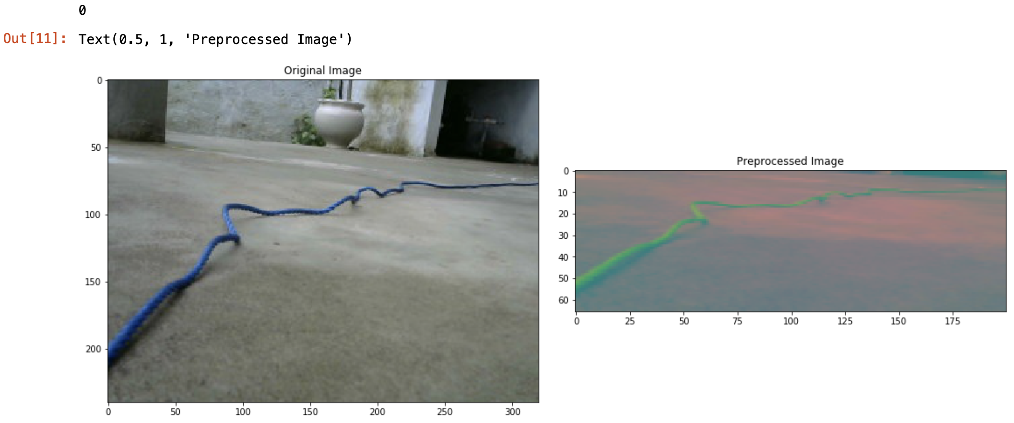

10.2.1 Original Image and Preprocessed Image

# In[12]:

def batch_generator(image_paths, steering_ang, batch_size, istraining):

while True:

batch_img = []

batch_steering = []

for i in range(batch_size):

random_index = random.randint(0, len(image_paths) - 1)

if istraining:

im, steering = random_augment(image_paths[random_index], steering_ang[random_index])

else:

im = mtimg.imread(image_paths[random_index])

steering = steering_ang[random_index]

im = path_preprocess(im)

batch_img.append(im)

batch_steering.append(steering)

yield (np.asarray(batch_img), np.asarray(batch_steering))

# In[13]:

def nvidia_model():

model = Sequential()

model.add(Convolution2D(24, (5,5), strides= (2,2), input_shape = (66, 200, 3), activation = 'elu'))

model.add(Convolution2D(36, (5,5), strides= (2,2), activation = 'elu'))

model.add(Convolution2D(48, (5,5), strides= (2,2), activation = 'elu'))

model.add(Convolution2D(64, (3,3), activation = 'elu'))

model.add(Convolution2D(64, (3,3), activation = 'elu'))

#model.add(Dropout(0.5))

model.add(Flatten())

model.add(Dense(100, activation = 'elu'))

#model.add(Dropout(0.5))

model.add(Dense(50, activation = 'elu'))

model.add(Dense(10, activation = 'elu'))

model.add(Dense(1))

model.compile(loss = 'mse', optimizer = Adam(lr = 1e-3))

return model

# In[14]:

model = nvidia_model()

print(model.summary())

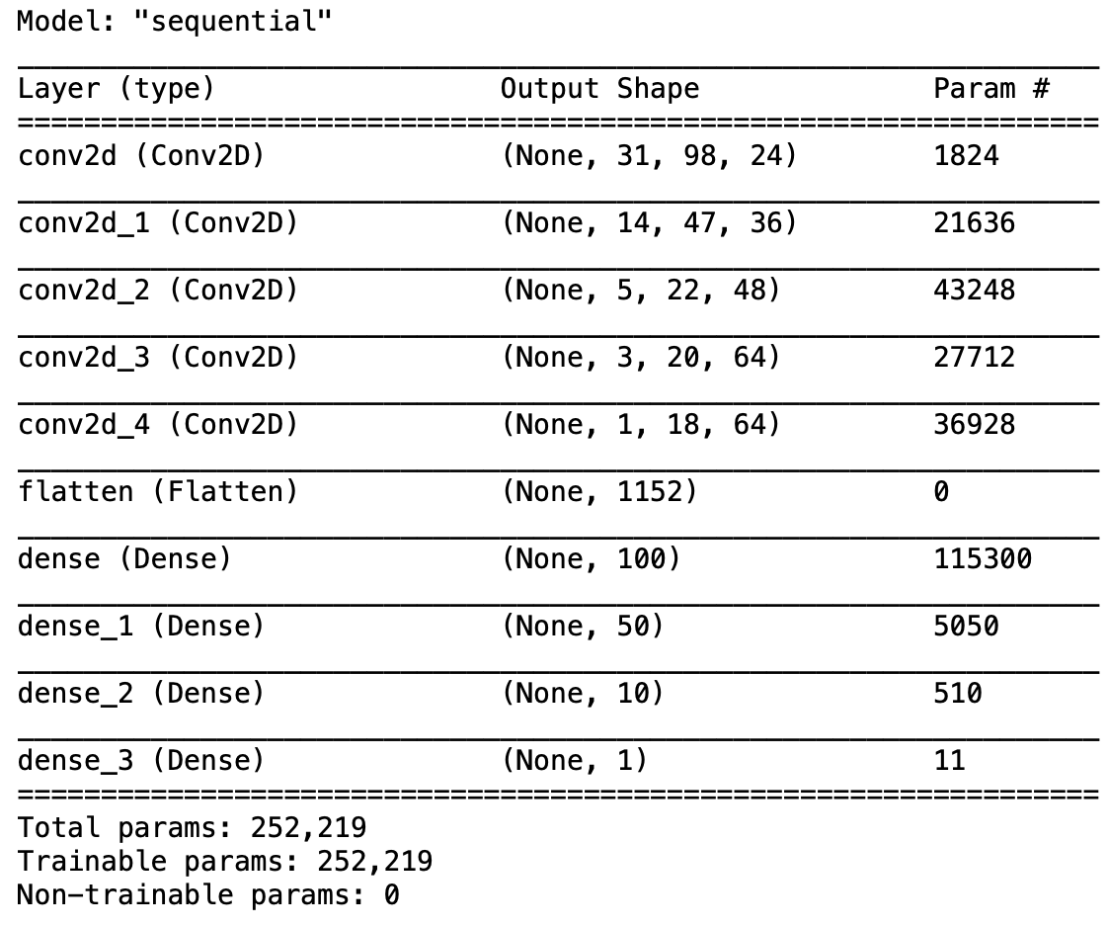

10.2.2 Model Summary

# In[15]:

history = model.fit_generator(batch_generator(X_train, Y_train, 100, 1), steps_per_epoch = 300, epochs = 10, validation_data = batch_generator(X_test, Y_test, 100, 0), validation_steps = 200, verbose = 1, shuffle = 1)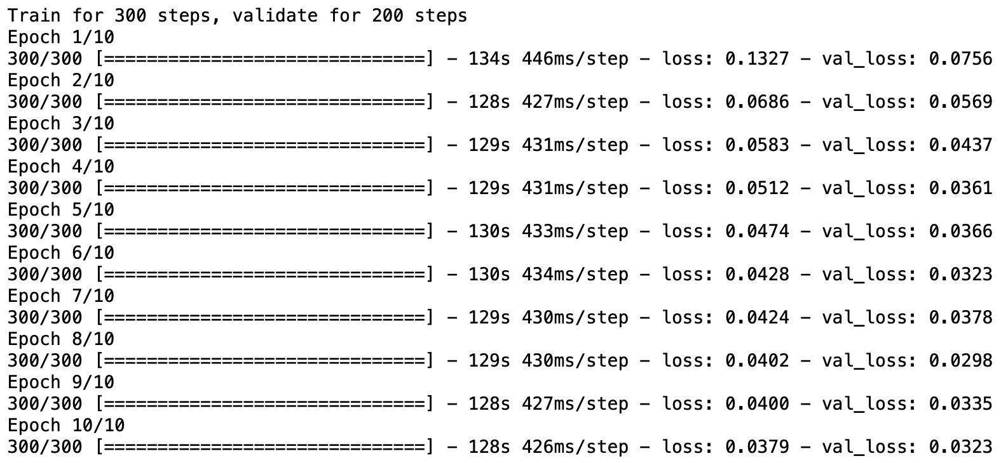

10.2.3 Training Steps

# In[16]:

plt.plot(history.history['loss'])

plt.plot(history.history['val_loss'])

plt.legend(['Training', 'Validation'])

plt.xlabel('Epoch')

plt.title(“Loss”)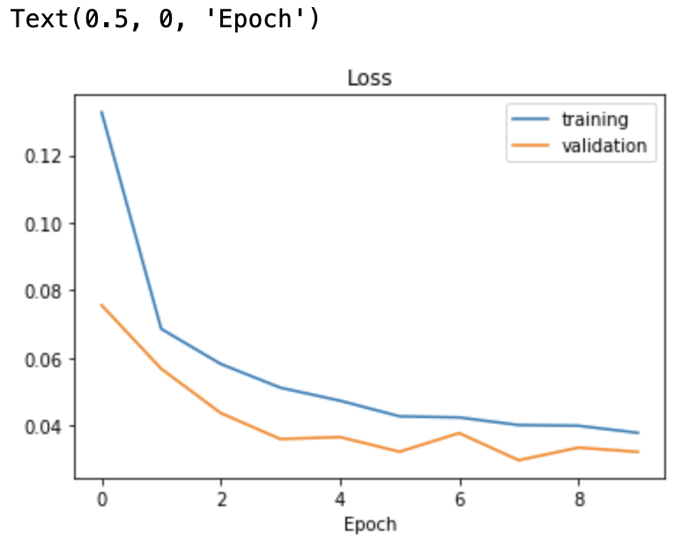

10.2.4 Loss vs Epochs graph

#In[17]:

model.save(‘driver.h5')

**Autonomous_mode.py**:

#imports

import socket

from vidgear.gears import NetGear

import pickle

from tensorflow.keras.models import load_model

from time import sleep

import cv2

import pygame

from pygame.locals import *

import numpy as np

import datetime

#Data preprocess

def path_preprocess(img):

img = img[0:300, :, :]

img = cv2.cvtColor(img, cv2.COLOR_BGR2YUV)

img = cv2.GaussianBlur(img, (3,3), 1)

img = cv2.resize(img, (200,66))

img = img/255

return img

def command_center():

print('Started')

global send_inst

global image

global command

global command_connection

global record

throttle = 1

angle = 90

data = {'throttle':0, 'speed':0, 'angle':90}

speed = 20

model_path = "driver.h5"

model = load_model(model_path)

pygame.init()

pygame.display.set_mode((250, 250))

send_inst = True

start = False

print("Thread Started")

host = '192.168.43.251'

command_port = 8001

video_port = '8000'

try:

command_socket = socket.socket()

command_socket.bind((host, command_port))

command_socket.listen(0)

command_connection, addr = command_socket.accept()

print("Connected to", addr)

print("Press 's' to start car\n Press 'w' to stop the car \n 1 - 50 \n 2 - 60 \n 3 - 70 \n 4 - 80\n Press 'q' to exit")

sleep(0.5)

server = NetGear(address=host, port=video_port, protocol='tcp', pattern=0, receive_mode= True)

while send_inst:

image = server.recv()

cv2.imshow("Car View", image)

if image is None:

print("Image is none")

break

for event in pygame.event.get():

if event.type == pygame.KEYDOWN:

key_input = pygame.key.get_pressed()

if key_input[pygame.K_s]:

start = True

elif key_input[pygame.K_w]:

start = False

elif key_input[pygame.K_1]:

speed = 50

elif key_input[pygame.K_2]:

speed = 60

elif key_input[pygame.K_3]:

speed = 70

elif key_input[pygame.K_4]:

speed = 80

elif key_input[pygame.K_ESCAPE]:

break

if start:

image = path_preprocess(image)

image = np.array([image])

angle = model.predict(image)[0][0]

angle = int(angle)

if angle < 0:

angle = 0

if angle != data['angle'] or throttle != data['throttle']:

command = {'throttle':1, 'speed':20, 'angle':angle}

data['angle'] = angle

data['throttle'] = 1

print(command)

command = pickle.dumps(command)

command_connection.send(command)

except:

cv2.destroyAllWindows()

server.close()

command_socket.close()

if __name__ == '__main__':

send_inst = True

command = 'a'

command_center()

**CHAPTER 11**

**TESTING AND RESULTS**

* The final built of the car is working perfectly.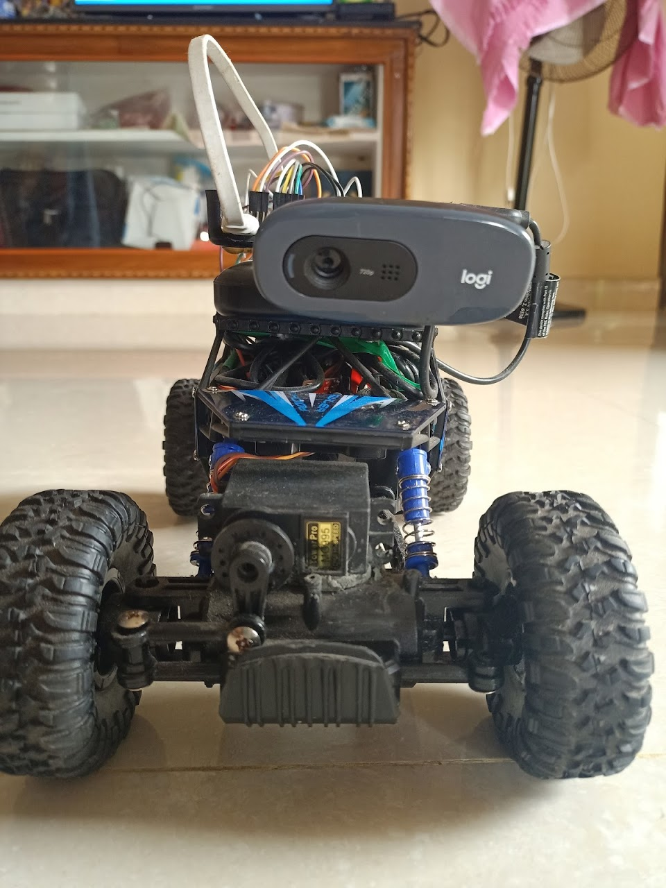

Fig 11.1 RC Car(Frontal view)

* The Manual mode is establishing the connection between the server and client successfully. And is enable the user to control the RC car using the keyboard.
* The Data capturing feature is also working perfectly, where the images captured and driving commands are stored in synchronous manner.
* After training the training mean square error loss is 0.0379 and testing mean squared error loss is 0.0323 which is an optimal value for model to train on real time data.
* Finally, The RC car is tested upon the road built using two ropes representing the edges.
* The results are promising and the car is able to guide its ways on the road that is between the ropes.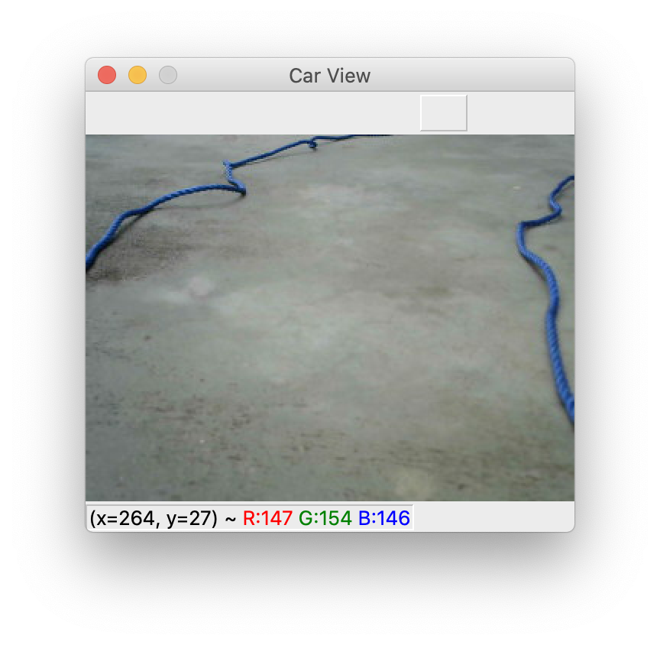
* Input for Nvidia Model:

11.2 Nvidia Model Input

* Output of Nvidia Model:



11.3 Nvidia Model output

* The Model was able to drive the car through the roads built using two ropes as edges of the road.
* Hence, The Model is predicting the steering angles accurately.
* Input of Modified LeNet model: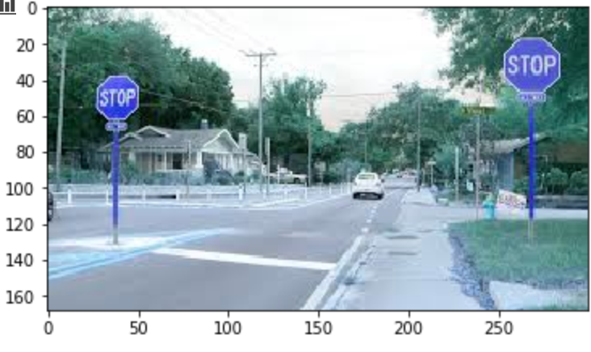

11.4 LenNet Model input

* Output of Modified LeNet Model: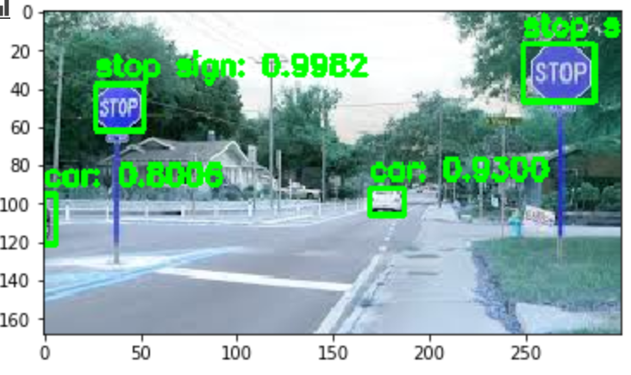

11.5 LeNet Model output

**CHAPTER 12**

**CONCLUSION**

In this Project, A Self Driven RC car has been build successfully using Python in a Server client model. Where the client is the RC car powered by a Raspberry pi and the server is the computer. Webcam, servo motor, raspberry pi, power bank, 18650 battery and TB6612FNG are mounted onto the RC Car to simulate a real time car. Server consists of two deep learning models, Nvidia Model and Modified LeNet Model which are responsible for Predicting Steering angle and detecting the objects respectively.

Finally, The RC car is able to drive on its own on the road but using ropes which represent the edges of the road. Later, The Autonomous mode of the car is even tested in different environment and results look promising.

Since this is a prototype, the RC car used is not perfect. The RC car components Raspberry Pi 3 and Motor driver TB11612FNG may overheat if operate for a long time. Because in autonomous mode, the Raspberry Pi need to keep process the image capture from the webcam. Besides that, the autonomous mode not able to operate at a dark surrounding or there are many things beside the track. As Raspberry pi having 1 GB RAM is used as the computer on the Client side and it has limited computational power which limits the addition of functions to the RC car and cannot run a neural network which results in using Server client model, leading a way to network delay. Due to this network delay, Server will not receive the Image frames on time. So, even though the model is accurate, this delay might cause in improper driving commands.

In Future, The raspberry pi can be replaced with much powerful mini computer having more powerful computational power that can host a neural network which will eliminate the Server Client architecture. GPS module can be added to the RC car that adds more sophisticated to the RC car.

**CHAPTER 13**

**BIBLOGRAPHY**

1. End-to-End Deep Learning for Self-Driving Cars, By [Mariusz Bojarski](https://developer.nvidia.com/blog/author/mbojarski/), [Ben Firner](https://developer.nvidia.com/blog/author/bfirner/), [Beat Flepp](https://developer.nvidia.com/blog/author/bflepp/), [Larry Jackel](https://developer.nvidia.com/blog/author/ljackel/), [Urs Muller](https://developer.nvidia.com/blog/author/umuller/), [Karol Zieba](https://developer.nvidia.com/blog/author/kzieba/) and [Davide Del Testa](https://developer.nvidia.com/blog/author/ddeltesta/) | [August 17, 2016](https://developer.nvidia.com/blog/deep-learning-self-driving-cars/)
2. Self-Driving RC-Car, By Doke Akshay M1, Shinde Vishal R2, Kumbhar Mangesh R3 Rai Nishant4, Prof S. B. Bhosale5 | October 17
3. <https://docs.python.org/3/howto/sockets.html>
4. Parth Verma (2012) The Google Autonomous Car. Available from:   
   https://sites.google.com/site/parthvermapaper/home/the-google-car
5. Putov Viktor Vladimirovich, Putov Anton Viktorovich, Ignatiev Konstantin Vasil'evich. Autonomous Three-Wheeled Robot with Computer Vision System. pp 262
6. Raspberry Pi. Available from:   
   https://en.wikipedia.org/wiki/Raspberry_Pi
7. Logitech HD Webcam C270 Technical Specifications (no date). Available from: http://support.logitech.com/en_us/article/17556